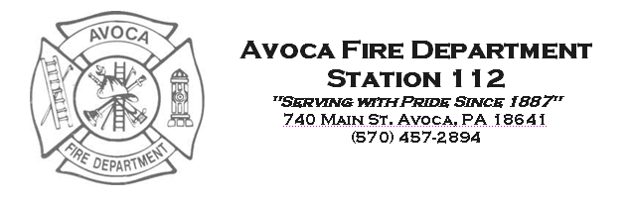

Suggested Operating Guideline: Knox Box

Purpose: This guideline provides accepted practices for the usage and maintenance of the department’s Knox Box keys.

General:
- The department’s Knox administrator will create a User ID for each member in the Knox software. Each member will create his or her own unique six digit PIN code to be used in conjunction with their assigned User ID. The User ID/PIN code combination will create audit trails for each usage of the Knox key.
- All firefighter level users will be required to have two (2) PIN codes to release a key. Both users will be marked as having removed the key in the units audit trail. Line Officers will not be required to use two (2) PIN codes.
- The Knox keys shall remain within the apparatus’ lock box at all times, unless it is needed to gain entry into a facility during an emergency response, or in a non emergency situation where the facility owner needs to replace/update keys.

Responses:
- When it is deemed necessary to use a Knox key during an emergency response, the following recommendations should be followed:
  - Notify Luzerne County 911 via radio that the knox key from Apparatus XXX is being released to gain entry.
  - Release the key using the required PIN code(s).
  - Open the facilities’ Knox box and retrieve all necessary keys. Make entry.
  - Upon incident completion, return all facility keys to the Knox box. Lock the box.
  - Return Knox key to the apparatus lock box.
  - Notify Luzerne County 911 via radio that the key has been returned to Apparatus XXX.

- Should any member encounter issues with a facilities’ keys during a response, ie: keys do not work, etc. they should advise a Chief Officer immediately after the incident’s completion.

Maintenance:
- In the event a facility owner/manager needs to update/replace keys in the Knox box, a line officer should be contacted and a date/time scheduled for the maintenance to take place.
- The responsible officer will advise Luzerne County 911 of the maintenance and ask that an incident be created.
- Upon completion of the maintenance and locking of the facilities’ Knox box, the officer should advise Luzerne County 911 that the Knox master key has been returned and that the incident is complete. The officer should also complete an incident report to document the entry and maintenance.

Audits:
- The department’s Knox administrator will be responsible for providing the Chief Officers an audit of each apparatus’ Knox unit monthly.
- The Chief Officers will review the activity and compare against department incident reports.
- Any release of the Knox key occurring outside of a documented incident, will be questioned by the Chief Officers.
- Members releasing a key outside of responses are subject to discipline as deemed appropriate by the Chief Officers.
- The audit trails will be kept as a permanent record of the department’s usage.

PIN Codes:
- Each member should treat their PIN code with the utmost confidentiality. PIN Codes should NOT be shared among members.
- Should a member forget his/her PIN Codes, they can be reset by contacting the department’s Knox administrator.
- The Knox administrator is responsible for removing PIN codes of inactive, retired or deceased members.

Authorized by:

________________________
Chris Van Luvender, Jr. – Chief

Originated: 10/17/2011

